**Python Installation**

Steps to download python in your system.

Step 1: Visit to site [www.python.org](http://www.python.org)

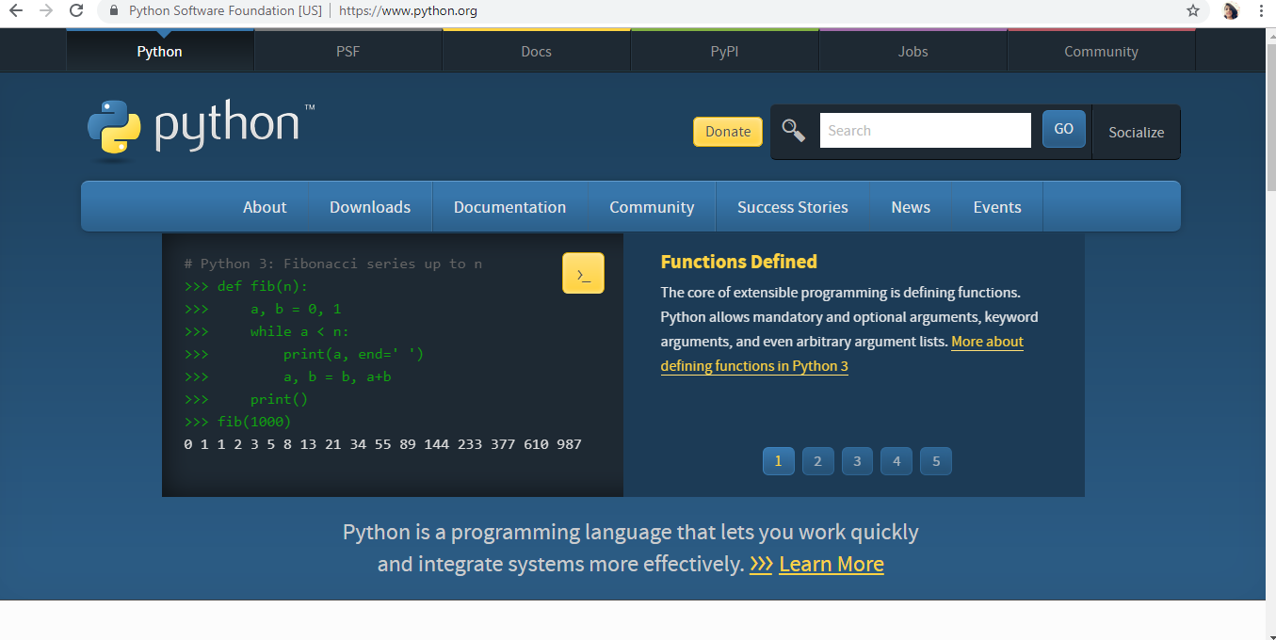

Step 2: Go to downloads and download Python 3.7.3

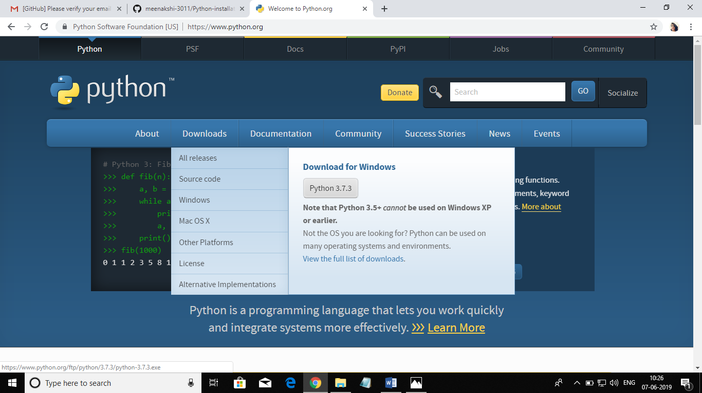

Step 3: Run the setup and install using customization installation, select the add python 3.7 to path option and also select all the additional optional files.

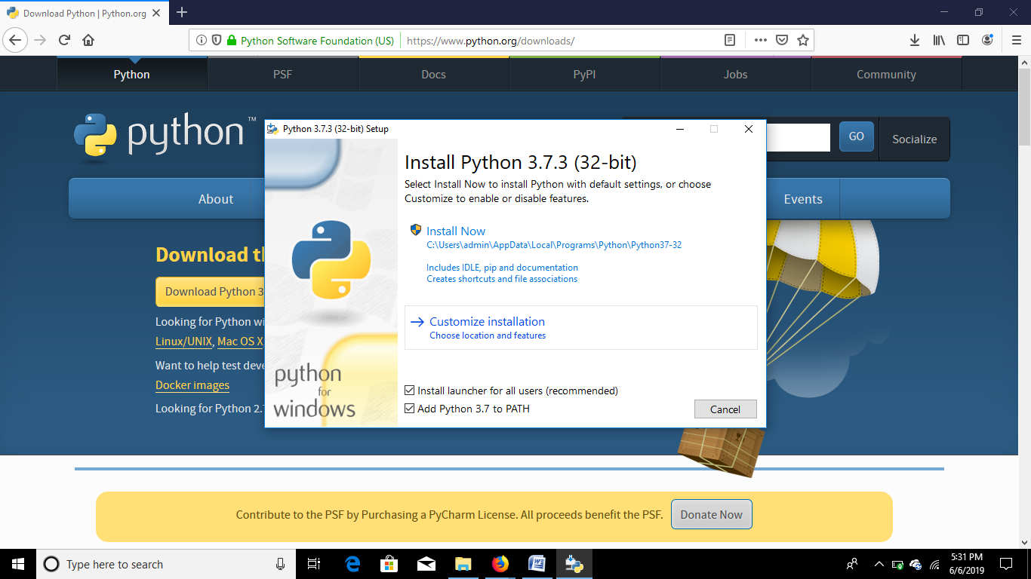

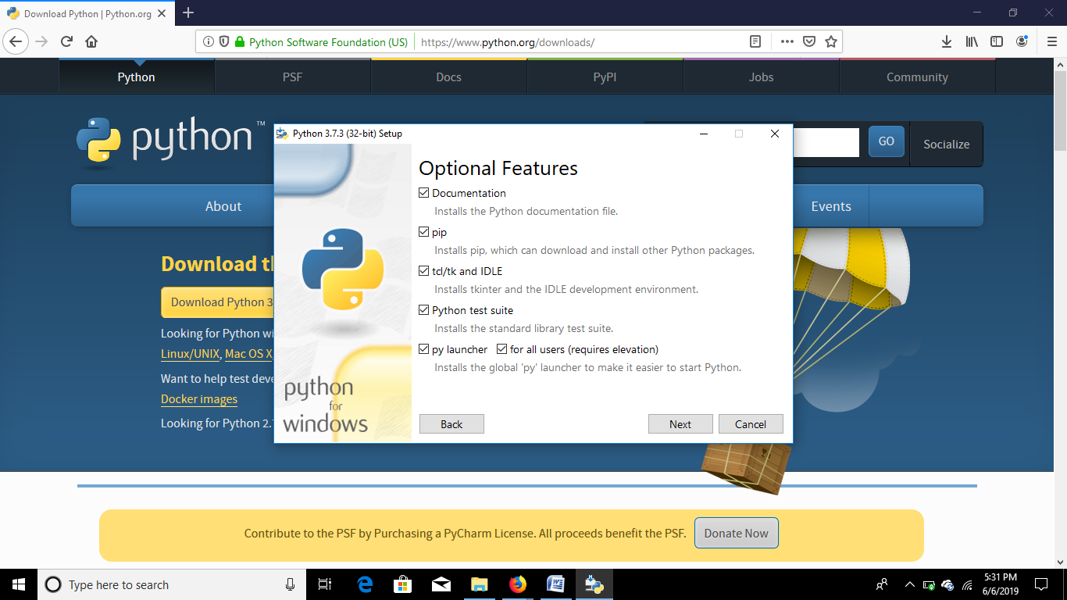

Step 4: Set path and install

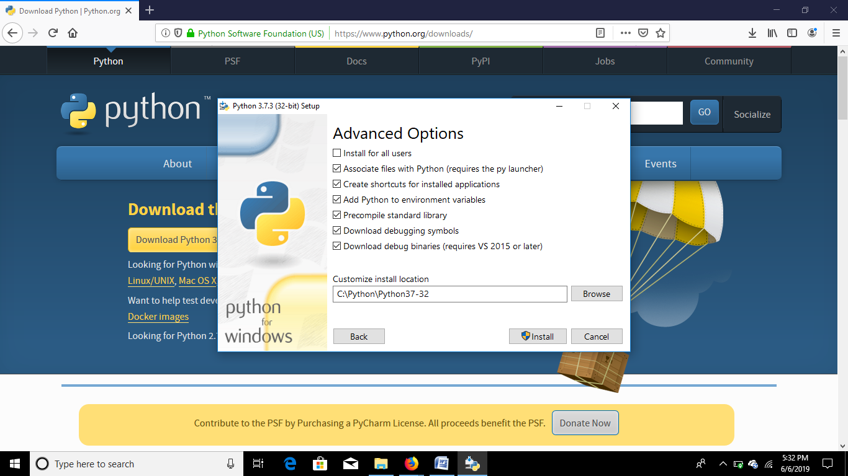

Step 5: To check whether the python is installed in your system go to command prompt and type python if the version is showing then it is installed and if not then it will show error.

